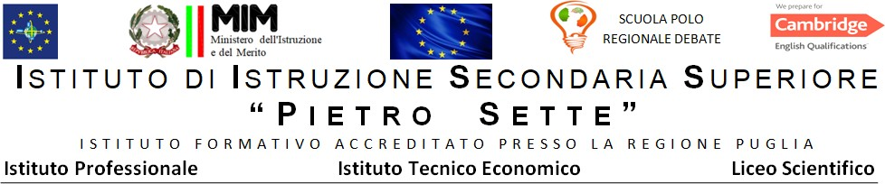

PROGRAMMA DISCIPLINARE DI Lingua e cultura inglese

Materia Inglese
Prof./ssa Gemmato Isabella
ClasseIV C LSSA
Libri di testo: Performer Shaping ideas vol 1

ARGOMENTI SVOLTI
Shaping ideas vol.1
The Elizathan theatre
All about Shakespeare ‘s Plays
All about Romeo and Juliet
Ex. The prologue pag 109
All About Hamlet
Ex To be or not to be pag.140
All about the Tempest
Ex. Prospero and Caliban.151
From Charles I to Commonwealth
The Puritans
ThePuritan Heritage
The Commonwealth a global partnership
The scientific Revolution
All about John Milton and Paradise Lost
Ex. Satan’s speech pag 186
Milton and Dante
The first Hanoverians
The birth of political parties
Augustan society
The birth of political parties
New means of expression
The coffeee house
The rise of the novel
All about Daniel Defoe
All about Robinson Crusoe
Ex the journal pag218
Ex man Friday pag 220
All about Jonathan Swift
All about Gulliver’s travels
Ex Gulliver and the Lilliputians pag233
The Industrial revolution

Santeramo in Colle,08/06/2024

Il/la docente
Isabella Gemmato

